**POLITICAL JUGGERNAU**TS **OF LOK SABHA 2019**

|  |  |  |
| --- | --- | --- |
| **Student Name** | **Team** | **Student NM id** |
| GOMATHI S | Team Leader | 2A67A17C4AD21E0B72D4D608D38FA4F5 |
| ANTONY FRANCIS P | Team Member | 8897500A991FE91A8F549FE9DD8A3927 |
| RAM JOTHIKA G | Team Member | 323A82E21537557B1F54125FD1FB08BF |
| NANDHA KUMAR S | Team Member | FFB8946D0990752A389460CAAA5DCAA4 |
| SAM DERANCE I G | Team Member | 3DB4BF0E875FC12AF764CC94D4B10117 |

**Content:**

1. **Introduction**
   1. **Overview**
   2. **Purpose**
2. **Problem Definition & Design Thinking**

**2.1 Empathy Map**

**2.2 Brainstroming Map**

**3. Result**

**4. Advantages & Disadvantages**

**5. Applications**

**6. Conclusion**

**7. Future Scope**

**8. Appendix**

**1. INTRODUCTION**

**1.1 Overview**

The Lok Sabha, constitutionally the House of the people, is the lower house of india's bicameral parliament, with the upper house being the Rajya Sabha. Members of the Lok Sabha are elected by an adult universal suffrage and a first-past-the-post system to represent their respective constituencies, and they hold their seats for five years or until the body is dissolved by the president on the advice of the council of ministers. The house meets in the Lok Sabha chambers of the parliament Houses, New Delhi.

The maximum membership of the house allotted by the constitution of india is 552 . Currently, the house has 543 seats which are filed by the election of up to 543 elected members. Between 1953 and 2020, two additional members of the Anglo- Indian community were also nominated by the President of India on the advice of Government of India, which was abolished in January 2020 by the 104th constitutional Amendment Act, 2019. The new parliament has a seating capacity of 888 for Lok Sabha .

A total of 131 seats are reserved for representatives of Scheduled Caste and Scheduled Tribes. The quorum for the House iis 10% of the total membership. The Lok Sabha, unless sooner dissolveed, continues to operate for five years from the date appointed for its first meeting. However, while a proclamation of emergency is in opeation, this period may be extended by parliament by law or decree.

**1.2 Purpose**

The Lok Sabha has certain power that make it more powerful than the Rajya Sabha. Motion of no confidence against the government can be introduced and passed in the Lok Sabha. If passed by a majority vote, the Prime Ministers and the Council of Ministers resign collectively.

Lok Sabha is the lower house of the India Parliament and has the primary responsibility of making laws. It can introduce bills and resolution, discuss them, and then pass them.

**2. Problem Definition & Design Thinking**

**2.1 Empathy Map**

An empathy map is a template that organizes a user’s behaviors and feelings to create a sense of empathy between the user and your team.  The empathy map represents a principal user and helps teams understand their motivations, concerns, and experience. Empathy mapping is a simple yet effective [workshop](https://frescopad.com/virtual-workshop-definition/) that can be conducted with various users in mind, anywhere from stakeholders, individual use cases, or entire teams of people. Many teams, such as design teams, sales, product development, and customer service, can conduct it.  Essentially, an empathy mapping exercise is a practice that seeks to get inside the head of the customer as they interact with your product/service. While the main importance of an empathy map is creating empathy between you and the user, some other important facets of using one offer different benefits to your team. Creating an empathy map considers many factors in relation to the customer’s overall experience.  These could be the problems they handle, how they use the product/service within a larger team, and who experience the brunt of the problem.  These details are essential to creating a holistic view of their experience because they illuminate the problem in your team’s mind. This is equally as important and helps build an overall understanding of how users interact with your product/service. Empathy mapping is an important tool used in marketing, product development, and user experience design to identify and solve individuals’ or target audiences’ requirements, motivations, and experiences. Empathy mapping can be applied to various design thinking activities, including user research, brainstorming, and prototyping. It’s critical that users, on some level, enjoy using your product/service. They will eventually leave and use something else if they don’t enjoy it.  As a business manager, this should be avoided at all costs, and the easiest way to avoid turnover is by ensuring a positive customer experience. Empathy maps are the easiest way to break down your customer experience and highlight the areas you can target for improvement. By incorporating [surveys](https://www.questionpro.com/blog/surveys/) and lines of direct feedback, they serve almost as a usability test and a journey map. Not only can you realize where their experience is lacking, but by putting yourself in the user’s shoes, you gain a better perspective of how your product functions in general. By understanding this, you can find holes and flaws you didn’t know existed and take your product/service to another level. During an empathy mapping session, participants can interact to develop those flaws in an empathy map.

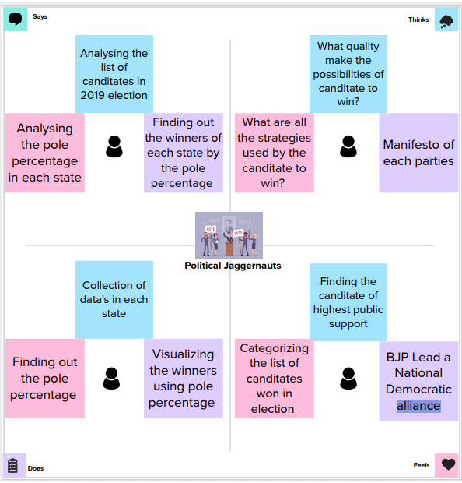

**2.2 Ideation & Brainstorming Map**

When brainstorming, or attempting to see a particular topic from all angles, linear tools — like lists — aren’t always the best solution. In fact, thinking this way can hinder creativity. The solution? A mind map. This organizational structure allows you to explore a central topic on a deep level through associated ideas and concepts which branch off from the center organically. On paper, a mind map resembles a tree, with your central topic at the center of the page. From there, lines (or *branches*) are drawn to sub-topics represented by keywords.  From here, you can go another level down with even smaller branches sprouting off into other related areas. With each new level, you move further away from obvious or surface level ideas and thoughts — that’s why a mind map can help you *fully* explore a topic, beyond face value.

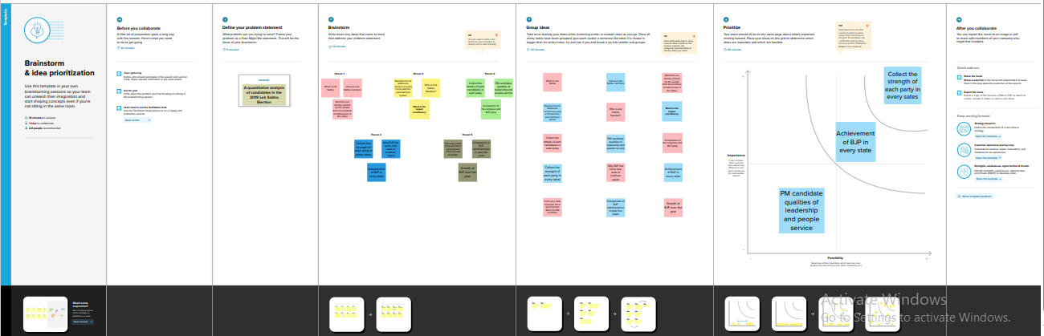

**3. RESULT**

**Activity 1.1(1)**

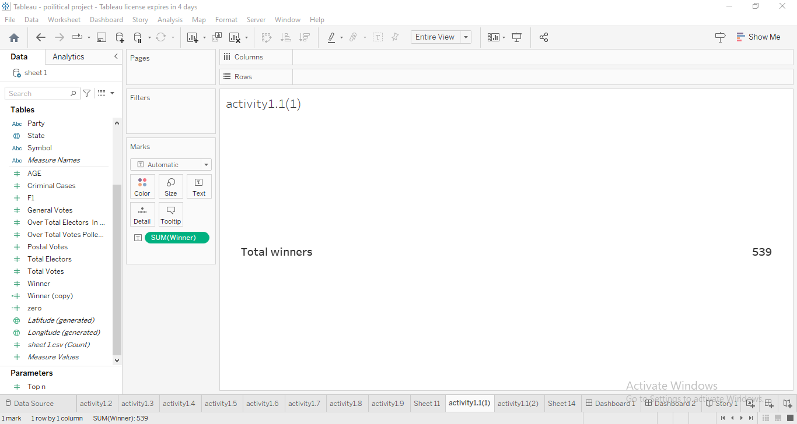

**Activity 1.1(1) - Story**

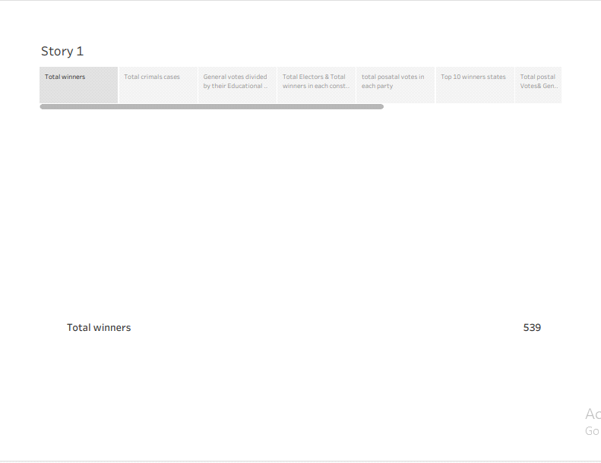

**Activity 1.1(2)**

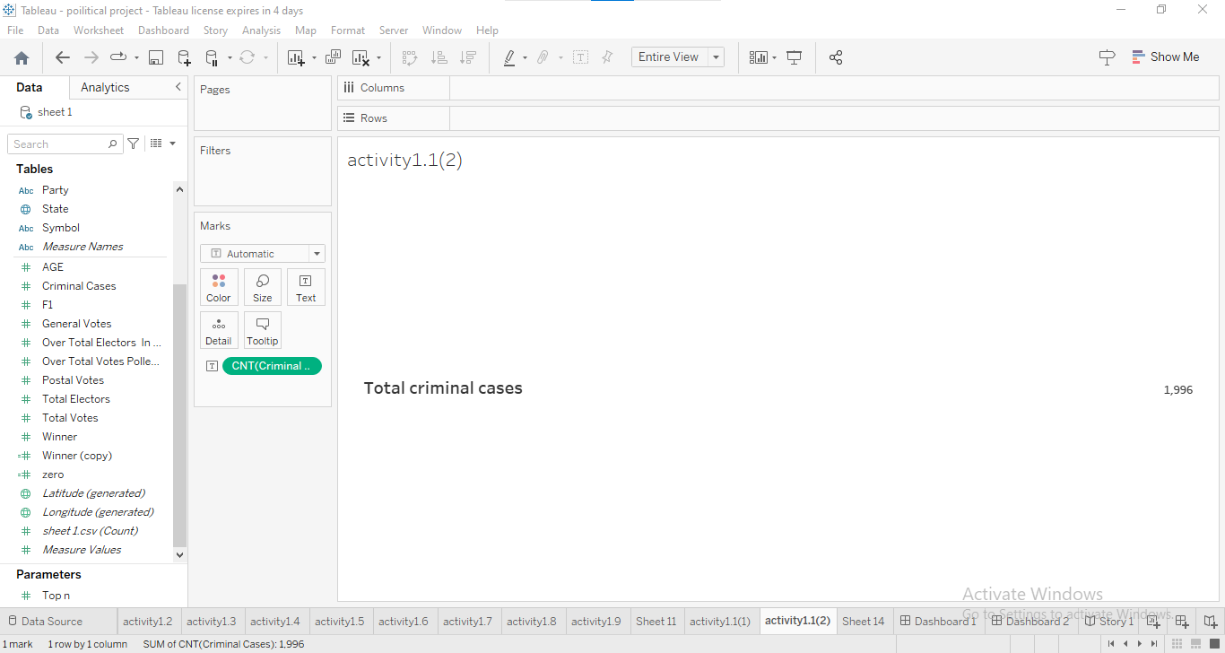

**Activity 1.1(2) - Story**

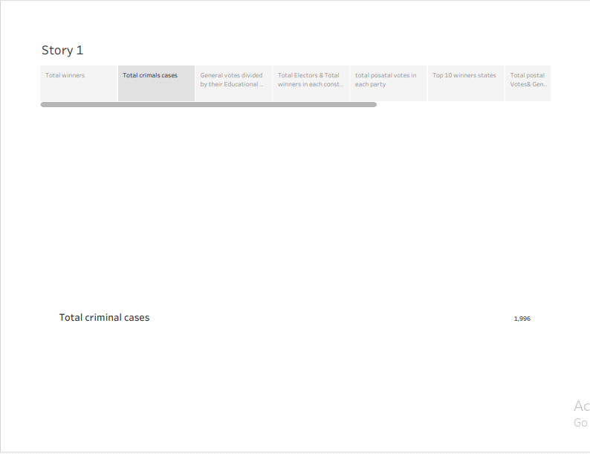

**Activity 1.1(3)**

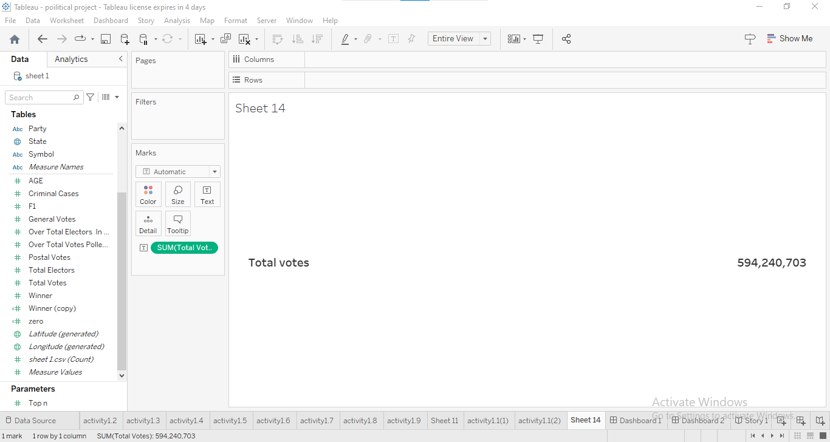

**Activity 1.2**

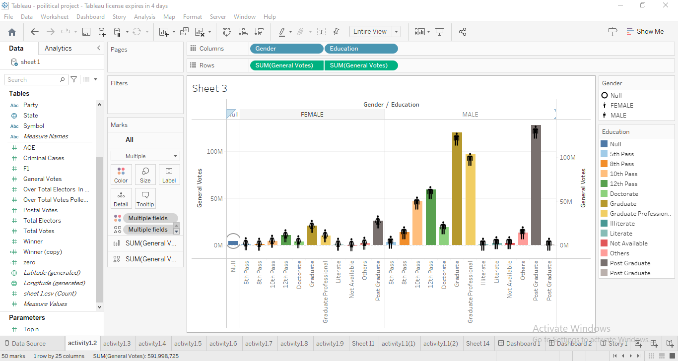

**Activity 1.2 - Story**

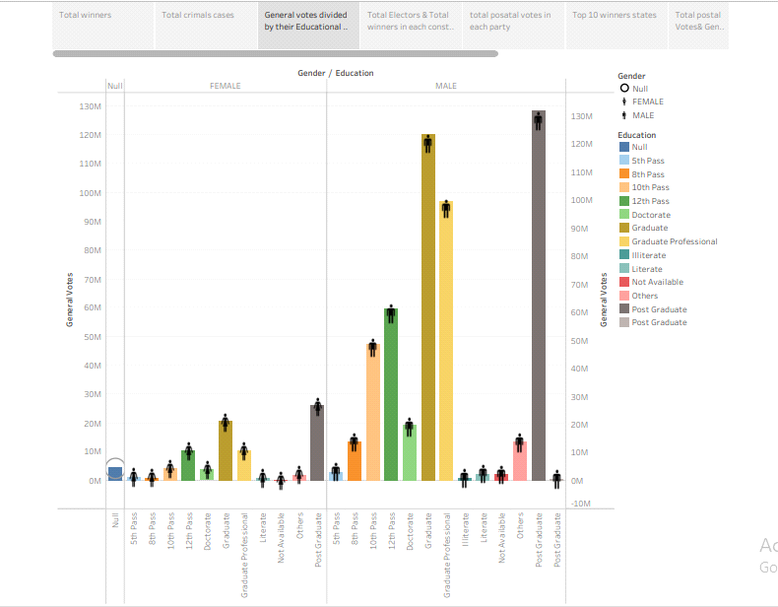

**Activity 1.3**

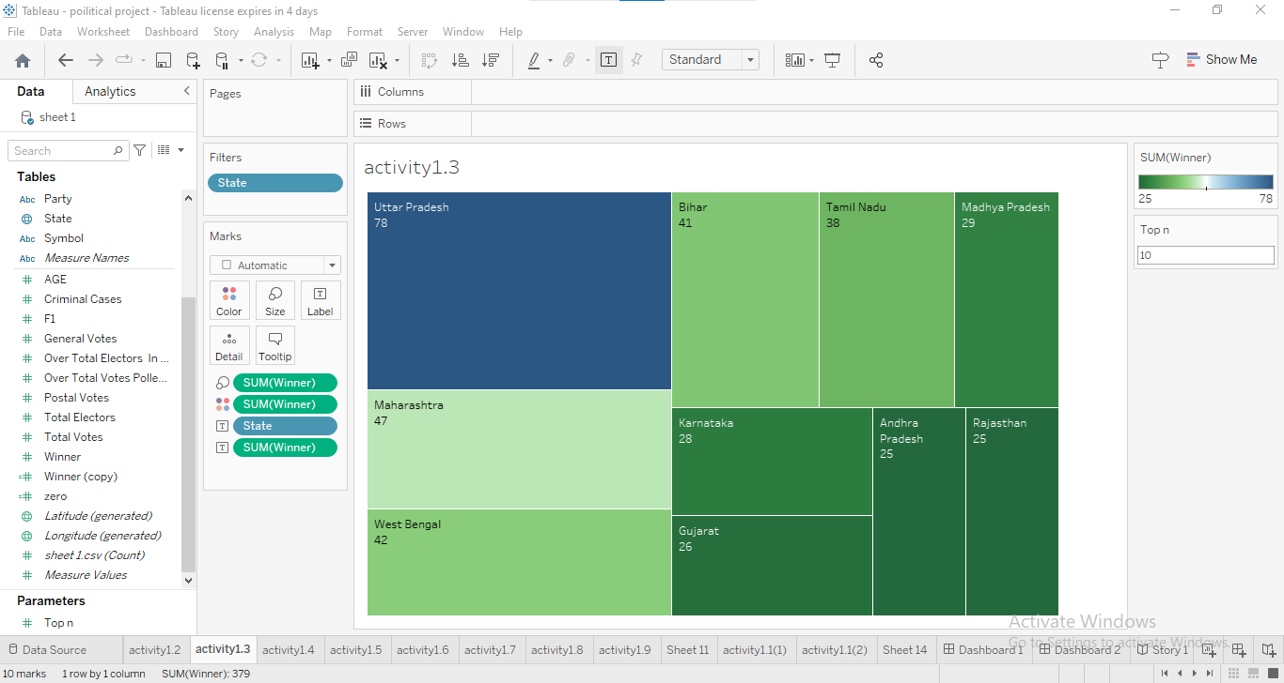

**Activity 1.3 - Story**

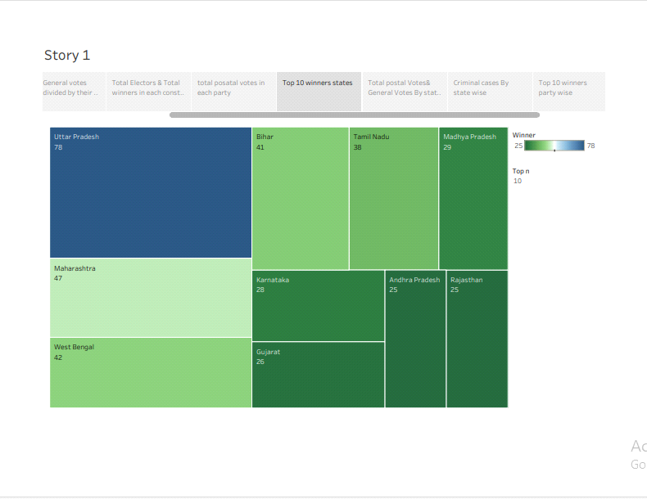

**Activity 1.4(1)**

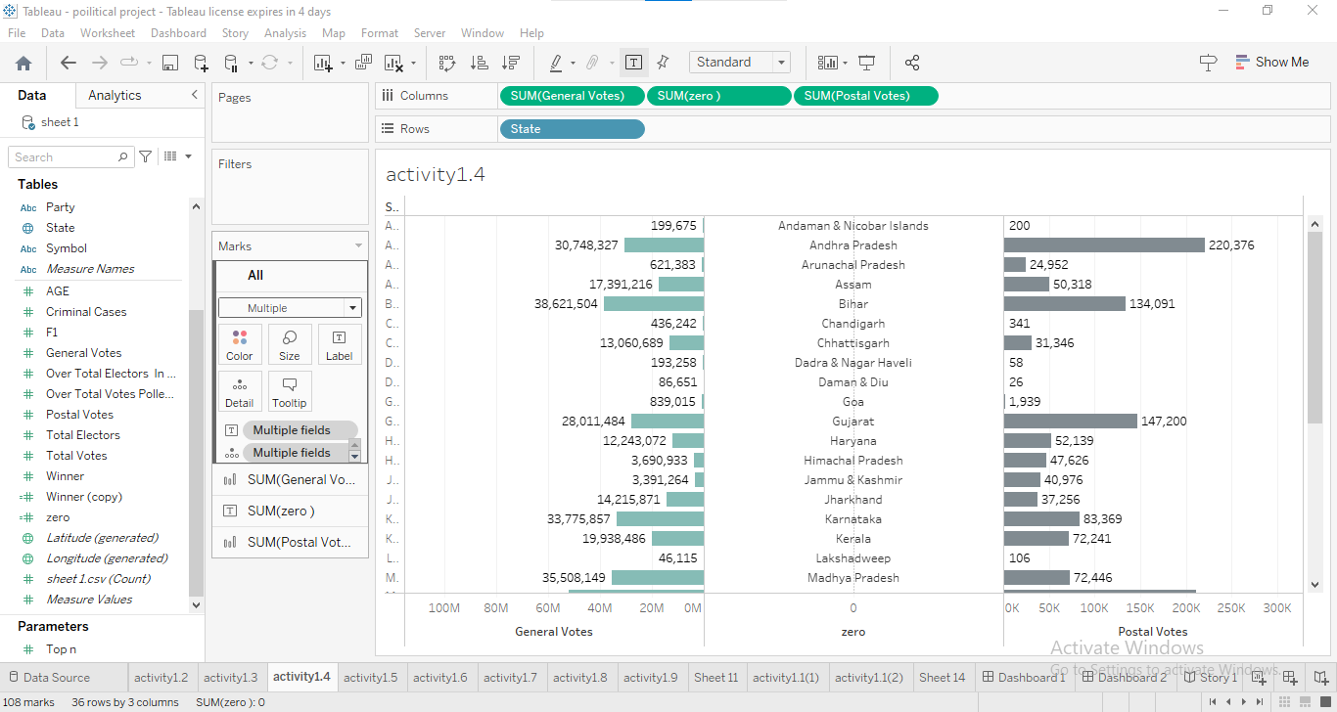

**Activity 1.4 (2)**

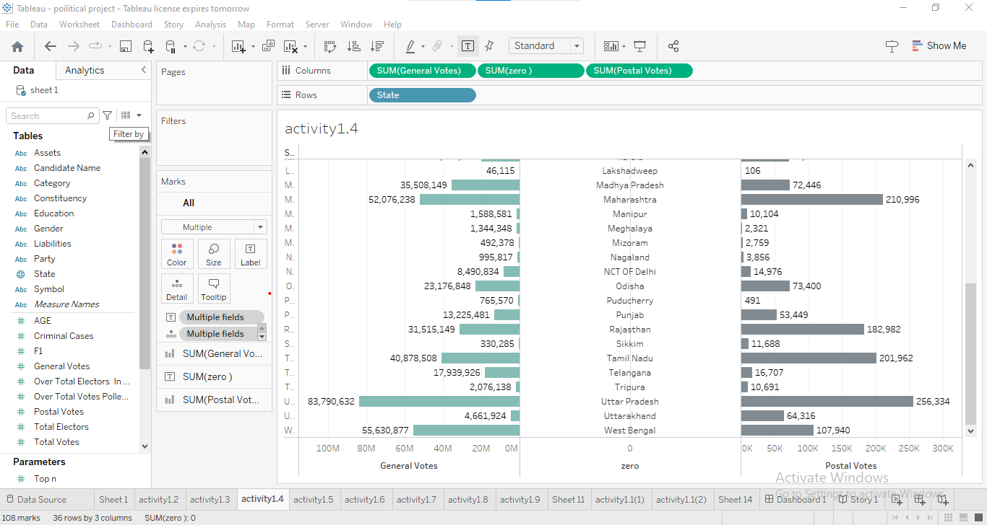

**Activity 1.4 (2) - Story**

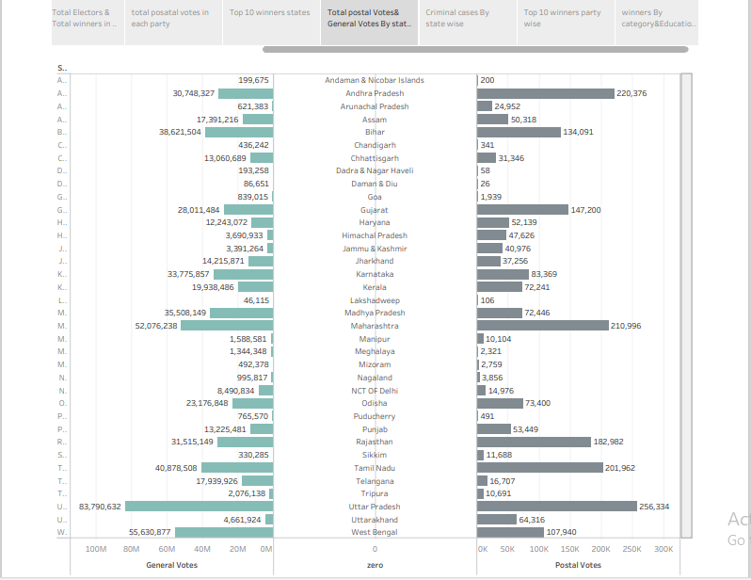

**Activity 1.5**

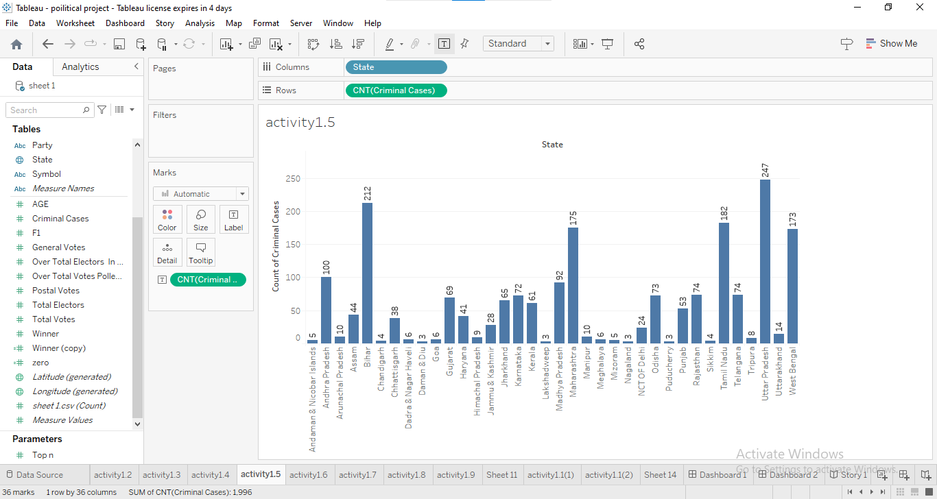

**Activity 1.5 - Story**

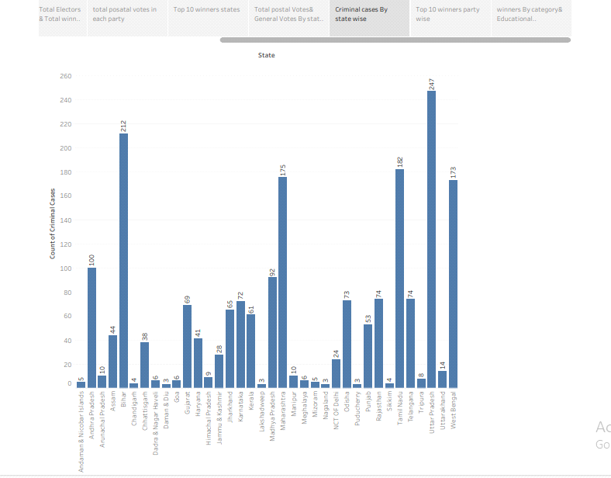

**Activity 1.6**

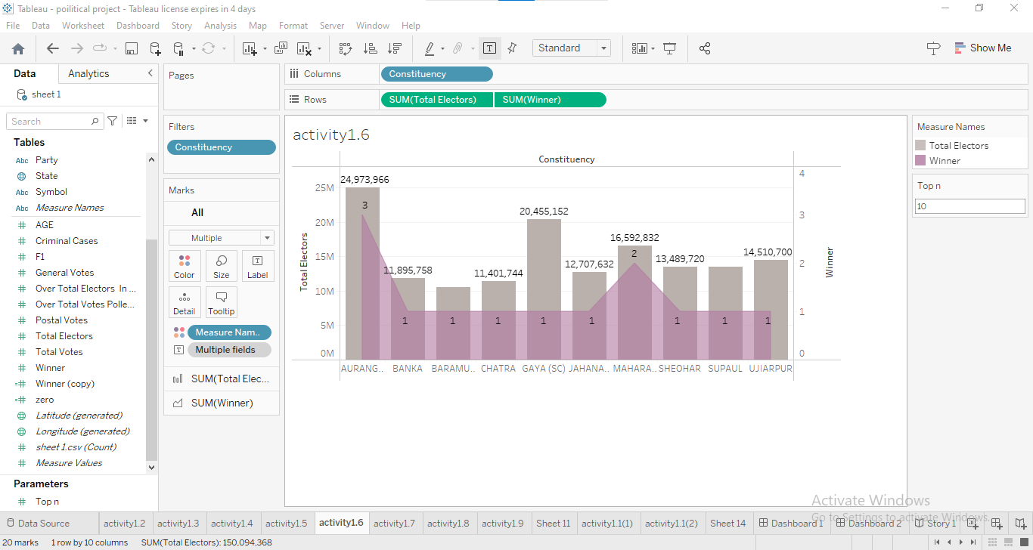

**Activity 1.6 - Story**

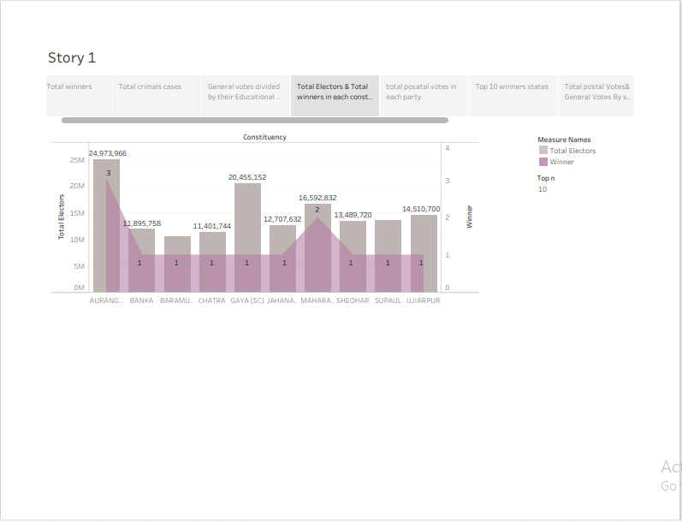

**Activity 1.7**

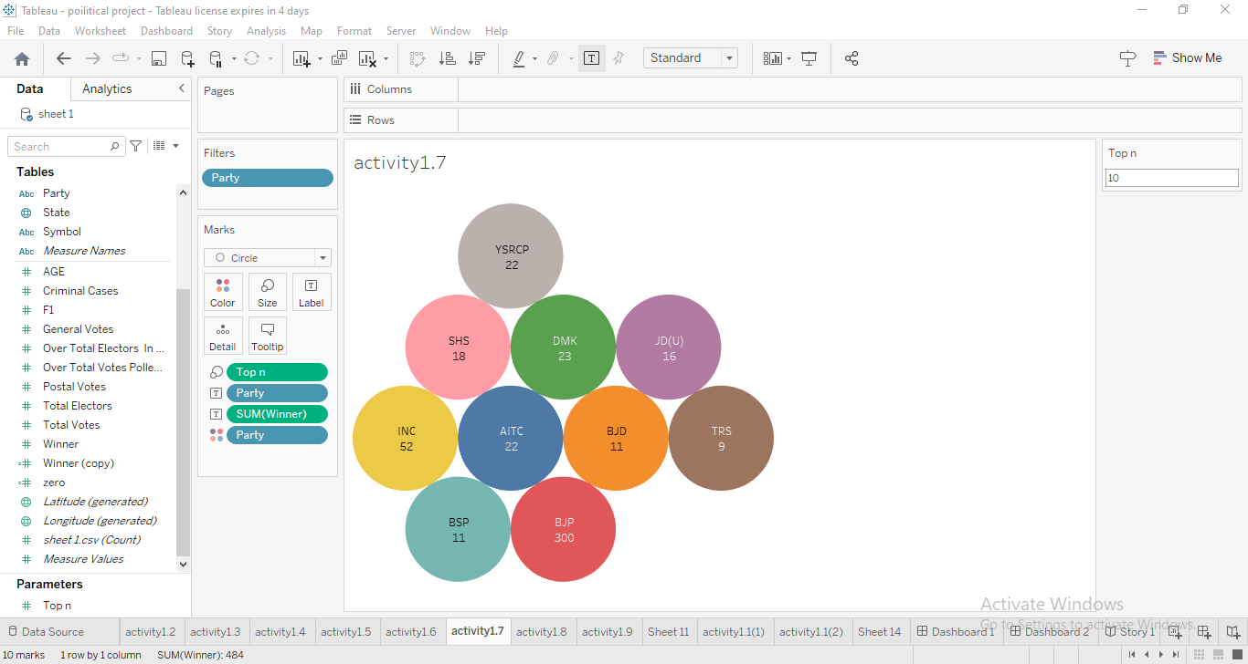

**Activity 1.7 - Story**

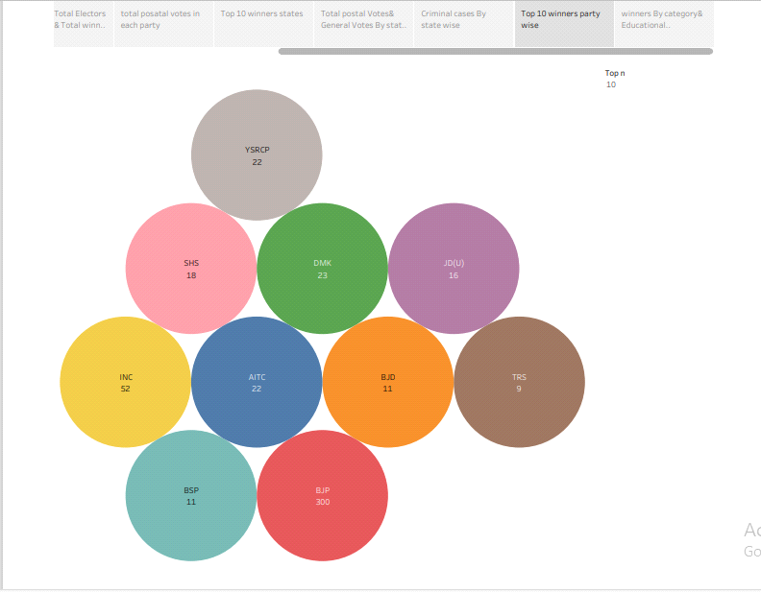

**Activity 1.8**

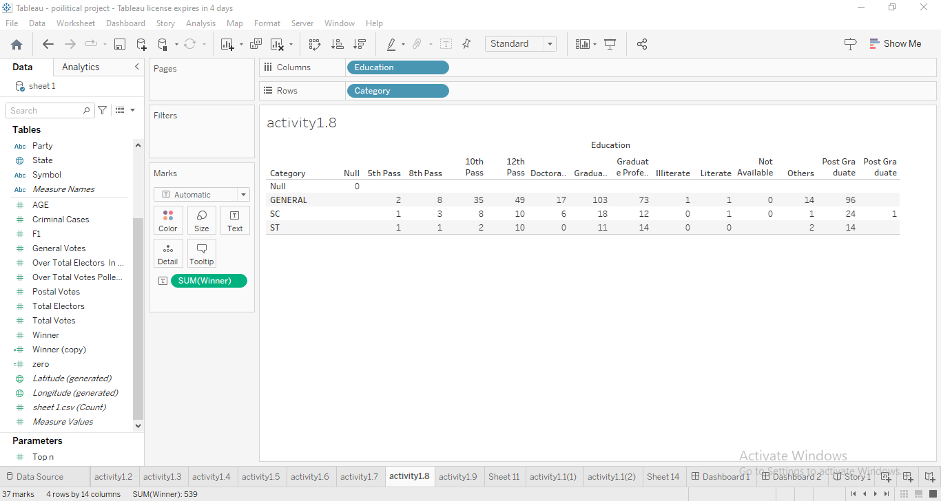

**Activity 1.7 - Story**

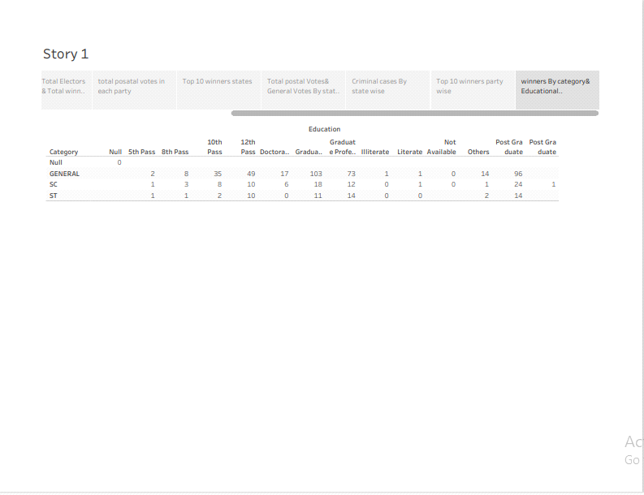

**Activity 1.9**

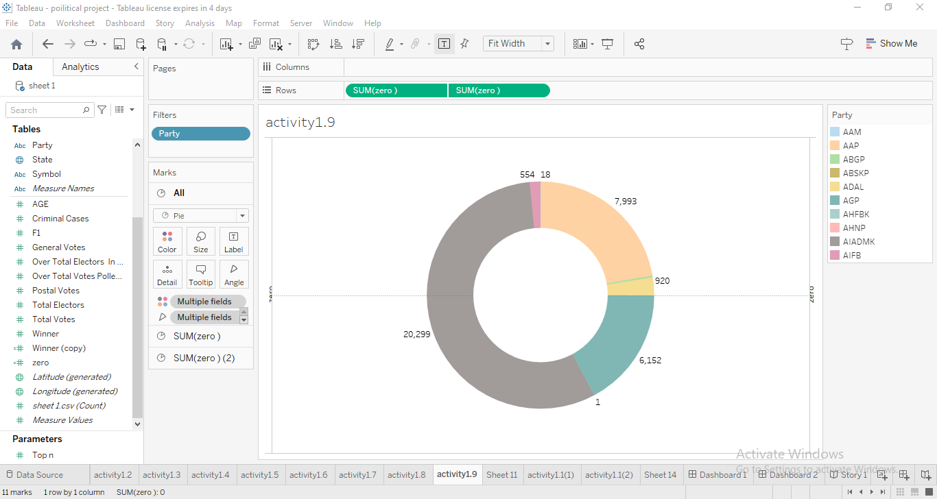

**Activity – 1.9 - Story**

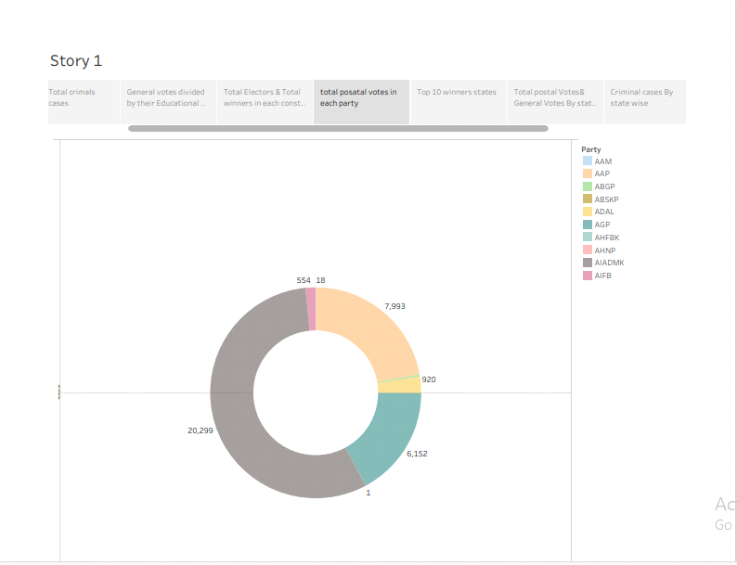

**Dash Board**

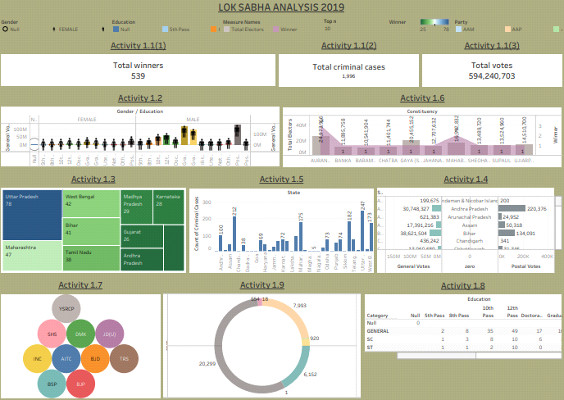

**4. ADVANTAGES & DISADVANTAGES**

**Advantages**

**Direct Representation of People:**

The Lok Sabha represents the people of India, and its members are directly elected by the citizens through general election. It is the primary legislative body that reflects the will and aspiration of the people.

**Popular Mandate:**

The party or coalition with a majority in the Lok Sabha form forms the government and selects the Prime Minister. The government dervies its legitimacy and mandate from the people's mandate expressed through Lok Sabha elections.

Financial Matters and Money Bills:

Money bills, which exclusively deal with financial matters, can only be inntroduced in the Lok Sabha. It has the final say on financial matters, providing stability to the government's fiscal policies.

**Executive Accountability:**

The Lok Sabha holds the government accountable for its actions and policies through various means, including question hour, debates, discussions, and no-confidence motion. The government is answerable to the Lok Sabha for its decisions.

Representative Democracy:

The Lok Sabha represents the principles of representative democracy, where the elected representatives make decisions on behalf of the people they represent. It ensures that the government remains accountable to the citizens and reflects their diversee interests.

**Disadvantages:**

**Party Politics and Whip System:**

Members of the Lok Sabha often vote along party lines due to the strong influence of political parties and the whip system. This can lead to reduced independent thinking and decision-making, as members might prioritize party interests over the interests of their constituents.

**Lack of Meaningful Debate:**

The Lok Sabha sometimes faces disruptions, walkouts, and adjournments due to the adversarial nature of Indian politics. This can result in a lack of meaningful debates on important issues, preventing comprehensive discussion and thorough examination of policies.

Shortcomings in Representation:

Depite the democratic structure, there can be issues related to the accurate representation of various groups, regions, and marginalized communities in the Lok Sabha. Some groups may be under represented, leading to policy decisions that do not adequately address their concerns.

**Dynastic Politics:**

The prevalence of dynastic politics, where family members of established politicians enter politics and secure positions in the Lok Sabha can hinder the emergence of new and diverse leadership, potentially limiting fresh ideas and perspectives.

Populism and Short-Terms Focus:

Members of Lok Sabha might be influenced by short-term populist measures to gain popularity among their constituents, potentially neglecting long-term developmental and strategic decisions.

**5. APPLICATIONS**

As per the provision of Article 79 of Indian Constitution, the House of the people, the Lok Sabha is the lower House of the parliament. Lok Sabha is composed of representatives of the people chosen by direct election on the basis of the adult suffrage.

Lok Sabha has certain powers that make it more powerful than the Rajya Sabha. Motions of no confidence against the government can be introduced and passed in the Lok Sabha. If passed by a majority vote, the Prime Minister and the Council of Ministers resign collectively.

**6. CONCLUSION**

In conclusion, the Lok Sabha is more powerful than the Rajya Sabha in almost all matters. Even in those matters in which the Constitution has placed both House on an equal footing. the Lok Sabha has more infulence due to its greater numerical strengh.

**7. FUTURE SCOPE**

Online voting present numerous vulnerabillities and is fundamentally insecure. There is potential for unobserved vote manipulation as well additional security vulnerabilities including potential denial of service attacks, malware intrusions, and privacy concerns. Online voting does not produce a paper trail for auditing.

Bolckchain-based voting, which relies on a decentralized, distributed digital ledger is vulnerable to many of the security flaws inherent in internet voting, such as the potential for malware to alter votes on a voter's local device before the ballots. Online and blockchain-based voting would greatly increase the risk of undetectable, nation-scale election failures.

**8. APPENDIX**

The committee, however, lament that time and again they have to perform the distastful duty of reporting upon matters of misbehaviour by Government officers with Members of Parliament. This becomes all the more lamentable inview of the fact that the Government of India have laid down clear guidelines for official dealings between the Administration and Members of Parliament. It seems to the compliance. In a democratic set up like ours everybody must realise that it is the people who are sovereign. The bureaucrats and the peoples' representatives have to strive together for the uplift of the masses. With this commonality of purpose, there should hardly be an occasion for any confrontation between the peoples' representatives and the bureaucrats. The committee feel that there is a great need to train officers at all levels of administration so that they show a little more tact and circumspection while dealing with Mps. After almost fifty years of independence, there is no pace for colonial hangovers and an ethos needs to be developed where nobody fights shy of extending unhesitating respect and courtesy to the peoples' representatives.

**Empathy & Brainstroming Map Link**

|  |
| --- |
| https://mail.google.com/mail/u/0/images/cleardot.gif  https://mail.google.com/mail/u/0/images/cleardot.gif |
|

<https://github.com/asmsu105msu10520211051522203/POLITICAL-JAGGERNAUTS_NM2023TMID06378>

**Dashboard Public Link**

<https://public.tableau.com/views/LokSabhaAnalysis2019_16963130549870/Dashboard1?:language=en-US&:display_count=n&:origin=viz_share_link>

**Story Public Link**

<https://public.tableau.com/shared/256BHD9ZP?:display_count=n&:origin=viz_share_link>

**Video Demonstration Link**

[**https://drive.google.com/file/d/1TsGH2ivWSeqbtW5ZhBc89kTWXDpa8X5w/view?usp=sharing**](https://drive.google.com/file/d/1TsGH2ivWSeqbtW5ZhBc89kTWXDpa8X5w/view?usp=sharing)